October 24, 2022

BCS203193

MUHAMMAD HARRIS

SECTION 4

Computer Organization & Assembly Language

LAB 04 – Practice Task

Practice Task

# Task 1

Write an assembly language program that allow user to input one-digit number and determine if it is even or odd.

## Code

.model small

.data

msg0 db 'enter a number: ', '$'

msg1 db 0ah, 0dh, 'number is even', '$'

msg2 db 0ah, 0dh, 'number is odd', '$'

.code

;initialize data segment

mov ax,@data

mov ds,ax

;print input string

lea dx,msg0

mov ah,9

int 21h

;taking input

mov ah,1

int 21h

;divide input by 2

mov bl,2

div bl

;moving modulus to al

mov al,ah

;comparing modulus to 0

cmp al,0

;if modulus greater than 0 jump to odd

jg odd

;else run even

even:

;print that number is even

lea dx,msg1

mov ah,9

int 21h

;jump to exit after printing

jmp exit

;code block for odd number

odd:

;print that number is odd

lea dx,msg2

mov ah,9

int 21h

;code block for exit

exit:

.exit

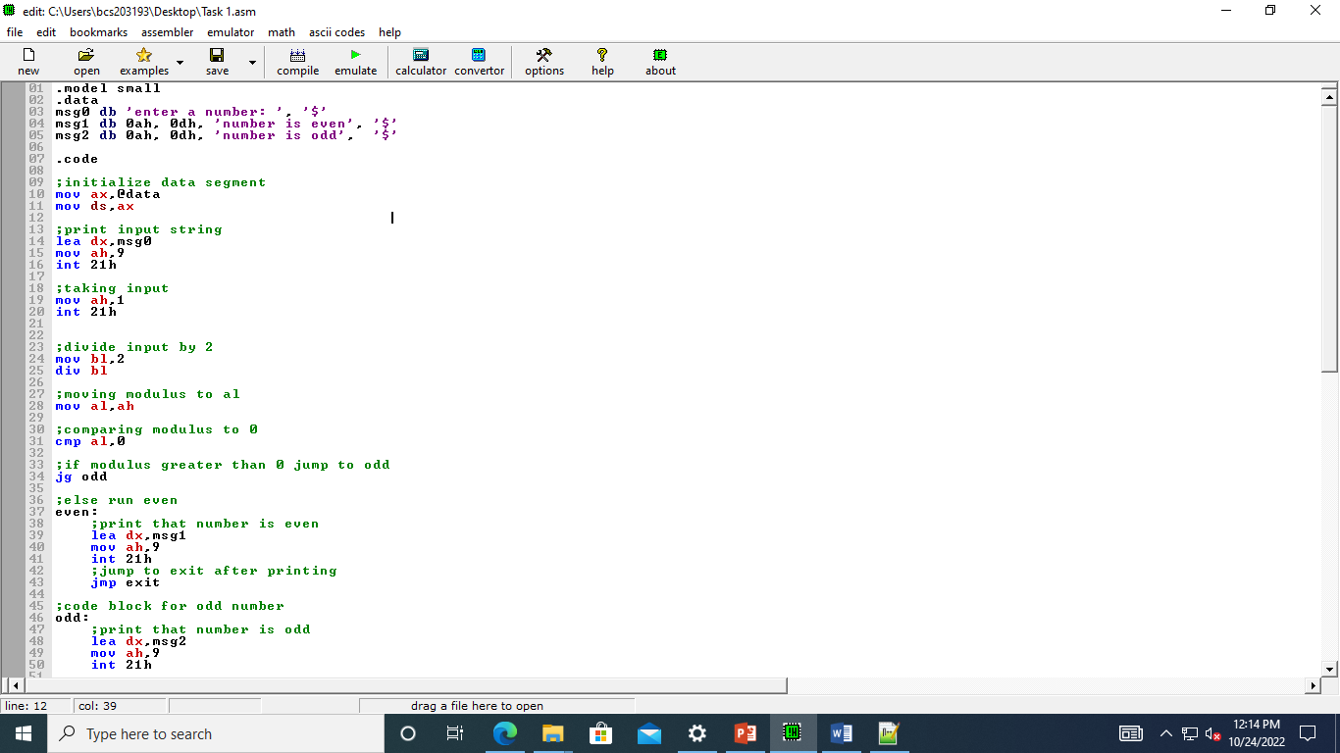

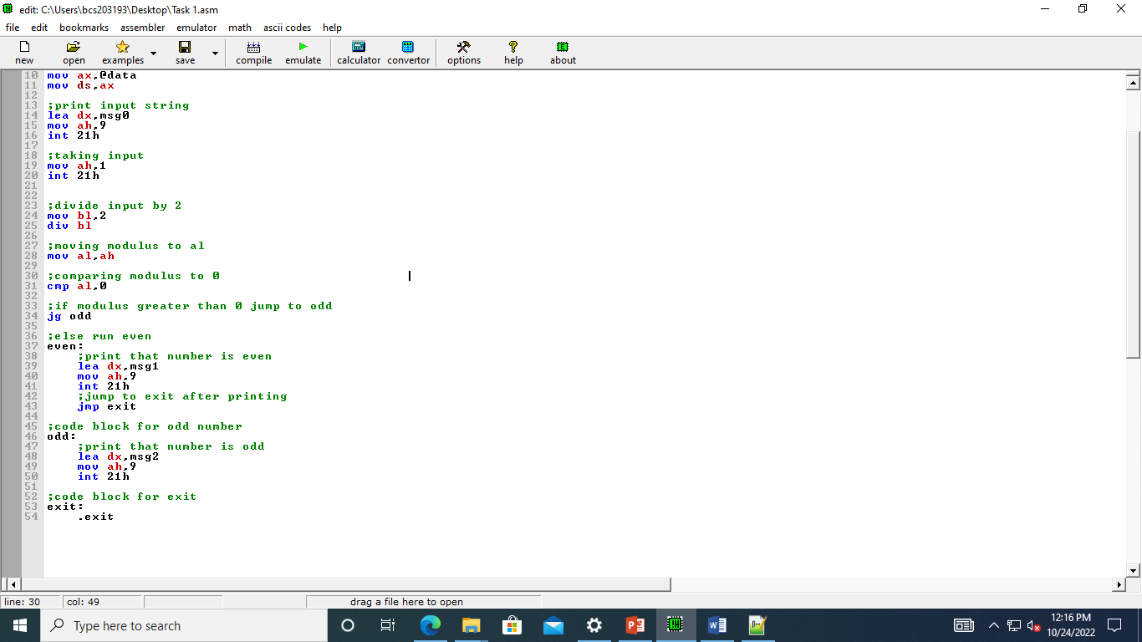

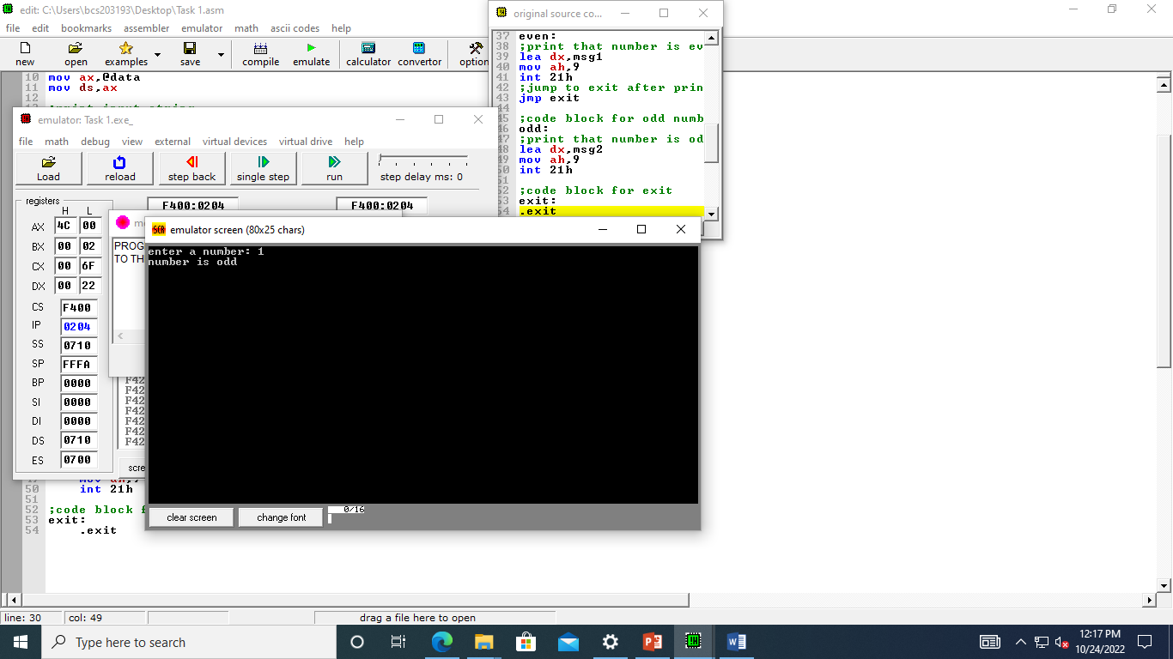

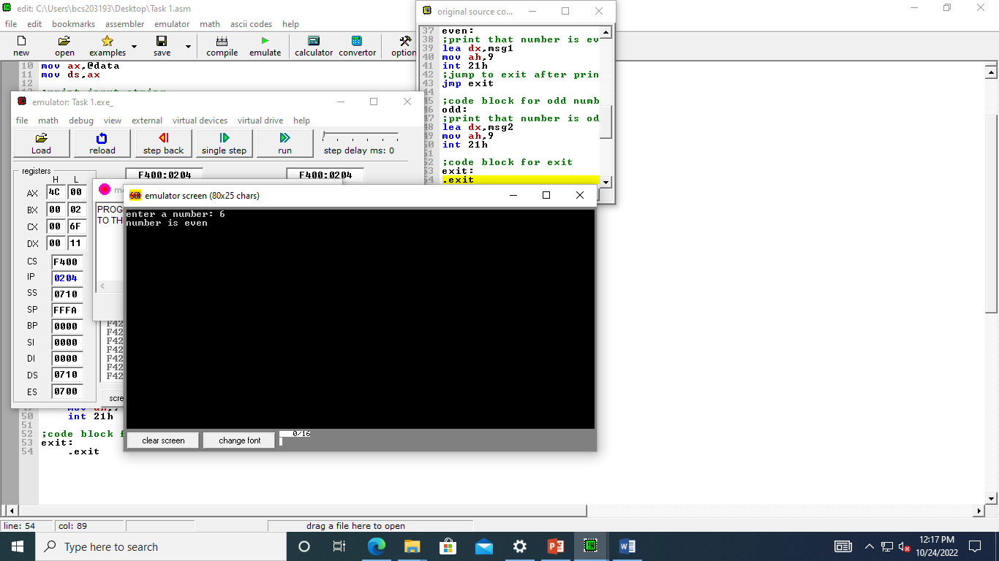

## Task 2

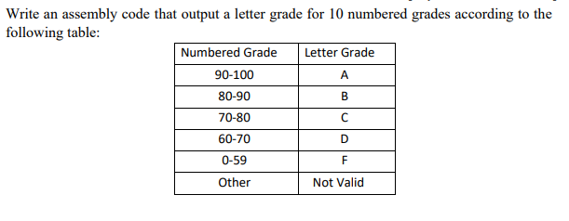

## Code

.model small

.data

msg0 db 'enter a number: ', '$'

msg1 db 0ah, 0dh, 'Grade is A', '$' ; Number >= 8 = A Grade

msg2 db 0ah, 0dh, 'Grade is B', '$' ; Number >= 5 && < 8 = B Grade

msg3 db 0ah, 0dh, 'Grade is F', '$' ; Number < 5 = F Grade

.code

;initialize data segment

mov ax,@data

mov ds,ax

;print input string

lea dx,msg0

mov ah,9

int 21h

;taking input

mov ah,1

int 21h

;fixing ASCII value

SUB al,30h

;comparing number to 8

cmp al,8

;if number greater than 8 jump to agrade

jg agrade

;comparing number to 5

cmp al,5

;if number less than 5 go to fgrade

jl fgrade

;else run b grade

bgrade:

;print that grade is b

lea dx,msg2

mov ah,9

int 21h

;jump to exit after printing

jmp exit

;code block for f grade

fgrade:

;print that grade is f

lea dx,msg3

mov ah,9

int 21h

;jump to exit after printing

jmp exit

;code block for a grade

agrade:

;print that grade is a

lea dx,msg1

mov ah,9

int 21h

;code block for exit

exit:

.exit

